TC-CMS-038
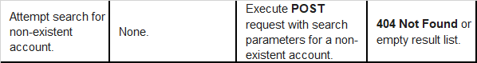
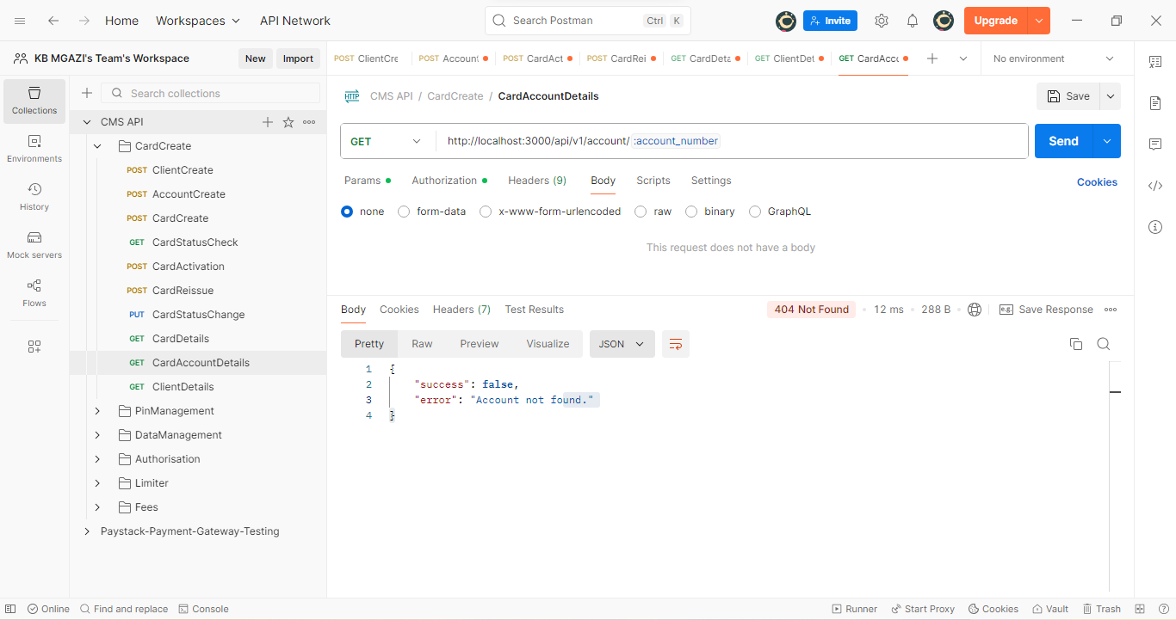
Response:
{
"success": false,
"error": "Account not found."
}

